BURGER SALES SQL QUERIES

1. **KPI’S**
2. Total Revenue

select sum(total_price) as total_revenue from Burger_Sales_table;

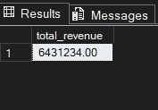

1. Average Order Value

select CAST(sum(total_price)/count( distinct order_id) as decimal(10,2)) as Average_order_value from Burger_Sales_table;

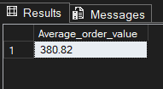

1. Total Burgers Sold

select sum(quantity) as Total_Burgers_sold from Burger_Sales_table where item_category like 'Burger%';

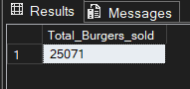

1. Total Orders

select count(distinct(order_id)) as Total_orders from Burger_Sales_table ;

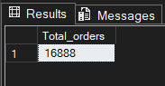

1. Average burger per Order

select cast (cast(sum(quantity) as decimal(10,2)) /

(select cast (count(distinct(order_id)) as decimal(10,2)) from burger_sales_table)as decimal(10,2))

as AVG_Burgers_per_order from Burger_Sales_table

where item_category like 'Burger%';

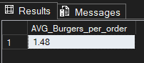

1. **Daily Trend For Orders**

select DATENAME(WEEKDAY,order_date) as week, Count(distinct(order_id))

as number_of_orders from Burger_Sales_table

group by Datename(WEEKDAY,order_date)

order by DATENAME(WEEKDAY,order_date);

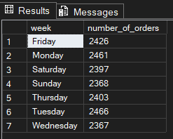

1. **Hourly Trend For Orders**

select datepart(HOUR,order_time) as Hour ,Count(distinct(order_id))

as number_of_orders from Burger_Sales_table

group by datepart(HOUR,order_time)

order by datepart(HOUR,order_time);

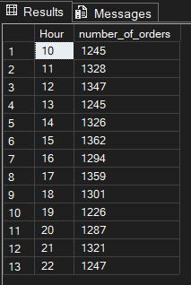

1. **Percentage of Sales by Item Category**

select item_category,round((sum(total_price)/(select sum(total_price) from burger_sales_table)),4)*100

as percentage

from burger_sales_table

group by item_category;

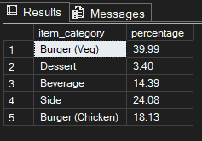

1. **Percentage of Sales by Item Name**

select item_name,round((sum(total_price)/(select sum(total_price) from burger_sales_table)),4)*100

as percentage

from burger_sales_table

group by item_name;

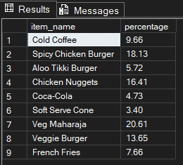

1. **Percentage of Sales through different Channels**

select channel,CAST((sum(total_price)/(select sum(total_price) from burger_sales_table)) as decimal(10,2))*100

as percentage

from burger_sales_table

group by channel;

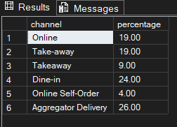

1. **Total Items Sold by Item Category**

create view TIS as

select item_category,sum(quantity)

as total_items_sold

from burger_sales_table

group by item_category;

select * from TIS;

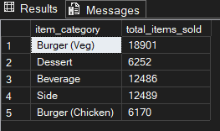

1. **Top 5 Best Selling items**

select top 5 item_name, sum(quantity) as Sold_Burgers

from burger_sales_table

group by item_name

order by sum(quantity) desc;

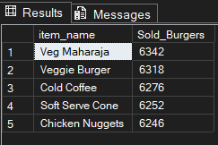

1. **Bottom 5 Worst Selling items**

select top 5 item_name, sum(quantity) as Sold_Burgers

from burger_sales_table

group by item_name

order by sum(quantity) asc;

